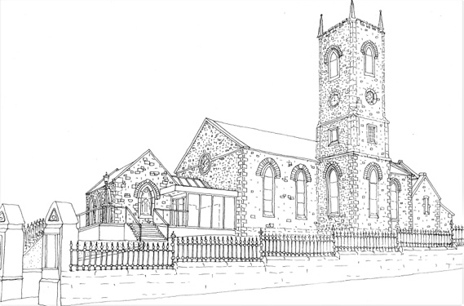
CHURCH OF IRELAND – DIOCESE OF CONNOR
ANGLICAN*EPISCOPAL

AGHERTON PARISH – CHURCH of ST JOHN the BAPTIST

Welcome to Agherton. Whether you are a visitor or a new parishioner, it is good to have you with us today and we hope you will enjoy your visit.

If you are new to the area and wish to join the Parish, please complete the form. We would like to get to know you and introduce you to our Church family.

All baptised Christians who are communicant members in their own tradition are welcome to receive the sacrament of Holy Communion according to conscience.

Malcom R.K Ferry ( Rector )
Email: aghertonparish@hotmail.co.uk

Please complete this form and hand it to one of the clergy or churchwardens before you leave church, or place in the collection plate, or email to the above address. Thank You

Name: …………………………………………………………………………………………………………………………………………

Address: ………………………………………………………………………………………………………………………………………

…………………………………………………………………………………………………………………………………………………….

Tel: ………………………………………

Mobile: ………………………………..

Email: ……………………………………………………………………………………………………………………………………………

Please tick if any of these interest you:

Sunday School (Sunday Surfers) Badminton

Creche Bowling

Church Choir Craft Club

Youth Fellowship Gardening Club

Mothers Union Wednesday morning Coffee Group

Church of Ireland Men’s Society Junior Boys Brigade

Bible Study Group Flower Arrangers Guild

Parish Hospitality Women’s Fellowship

